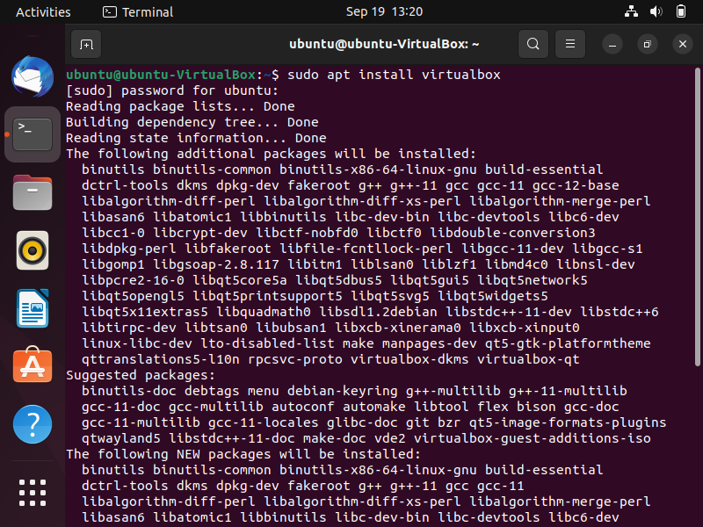 Step1: sudo apt install virtulabox: for installing virtualbox setup.

Step2: Press Y for continue. 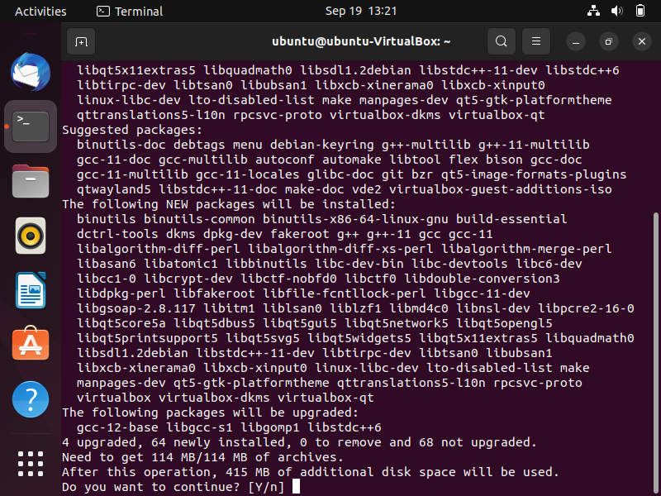

Step3: virt-manager: for launching QEMU Interface form terminal.

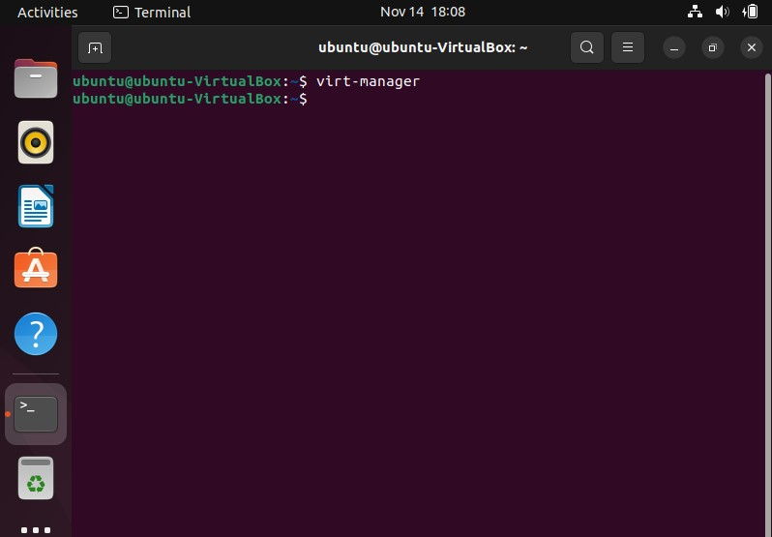

Step4: Click on New Button and Select name of Virtual Operating System i.e., Windows 7.

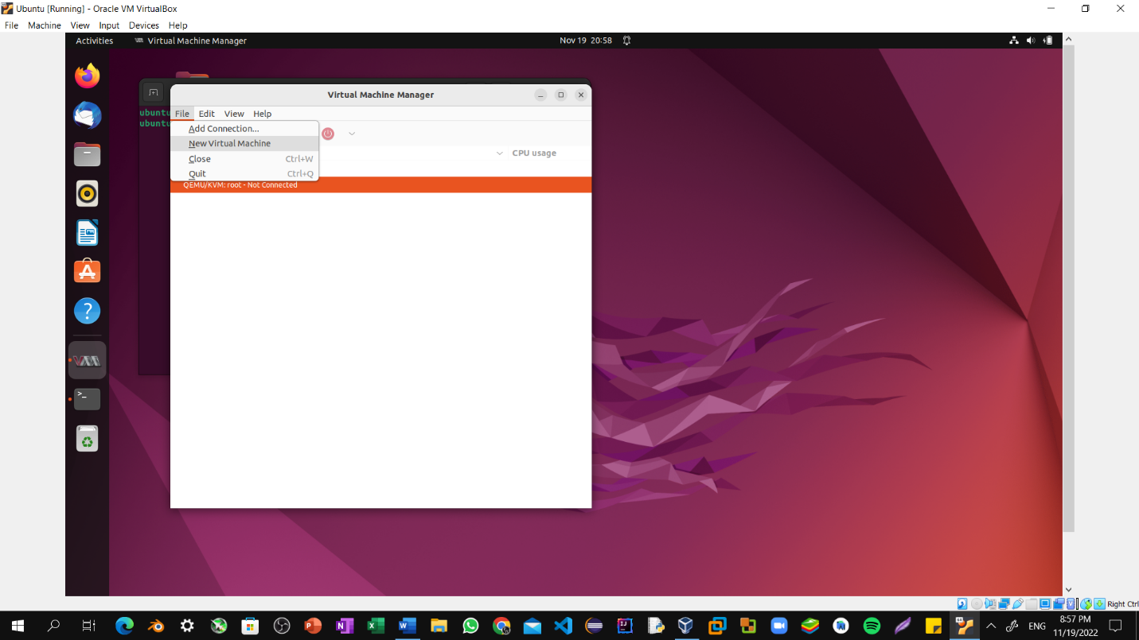

Step5: Now Select Memory Size depending upon the Usability.

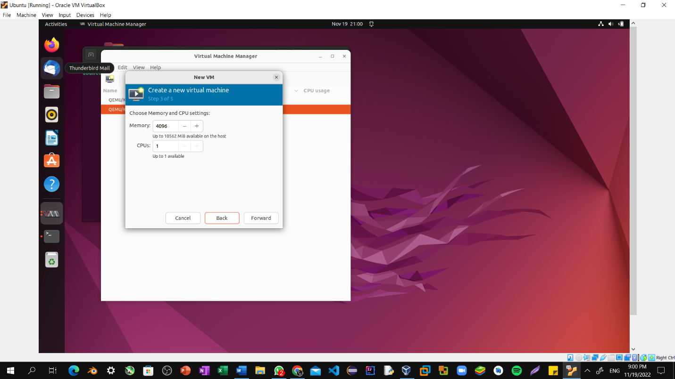

Step6: Select create a Virtual Hard Disk and click next.

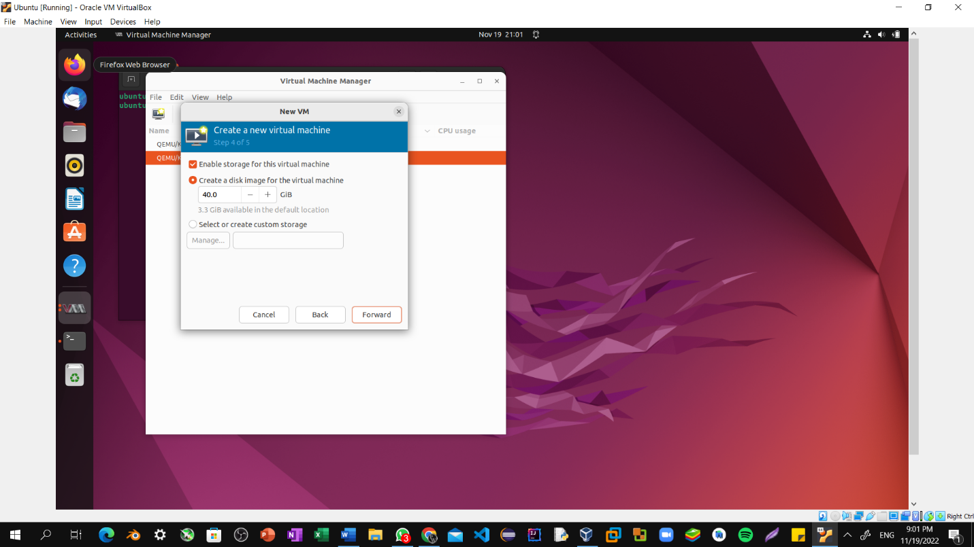

Step7: Then Select Install Windows10 and then on next.

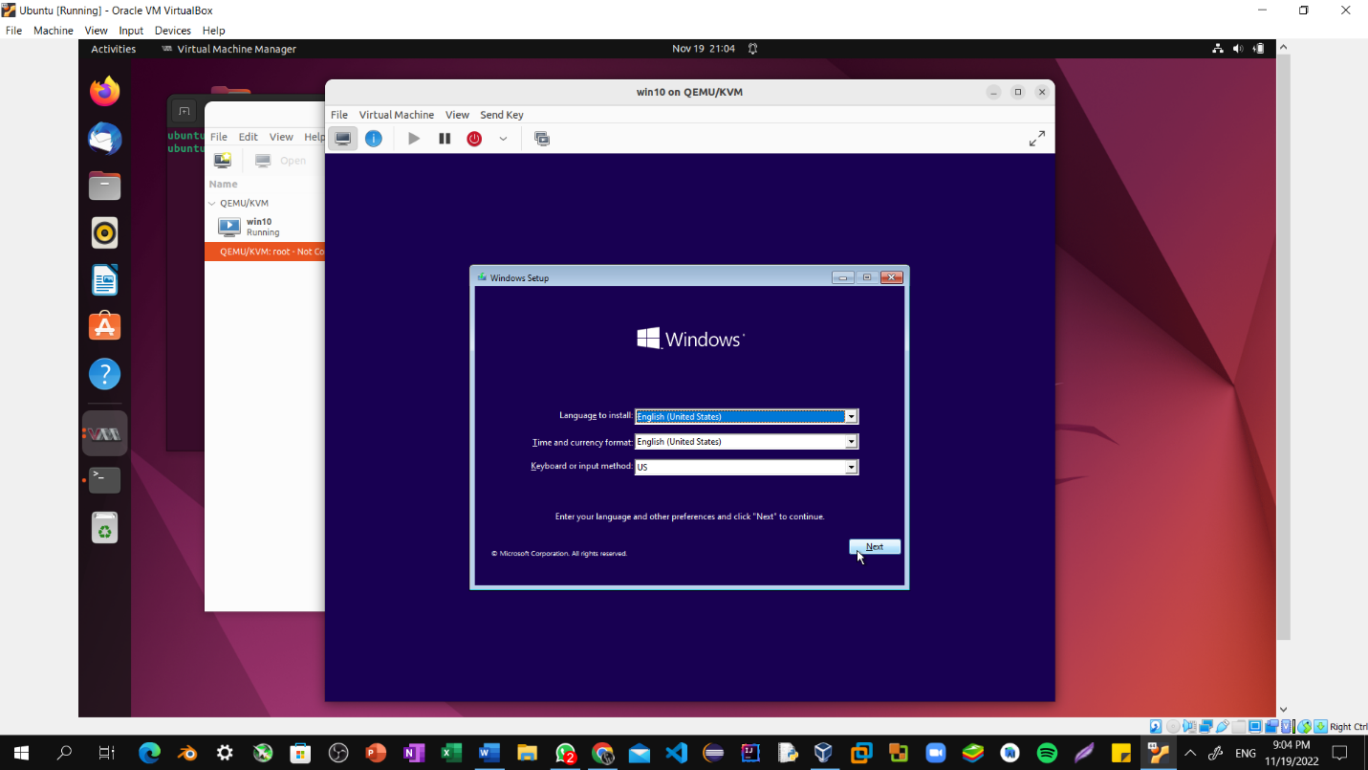

Step8: Select Windows 10 Home and proceed further by clicking on next.

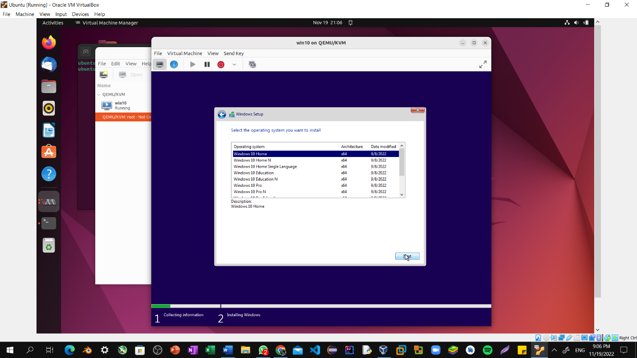

Step9: Check I accept the license terms and click on next.

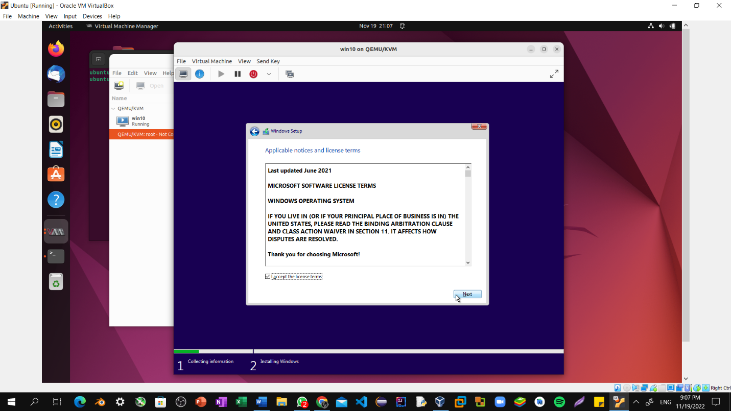

Step10: Getting Files ready for installation.

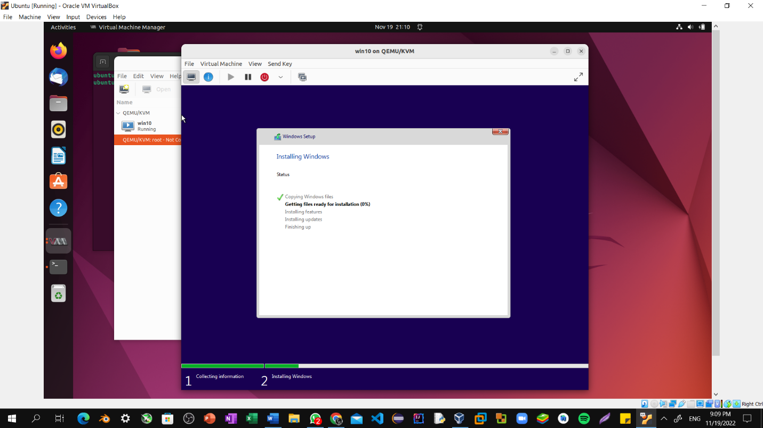

Step10: Wait For installation.

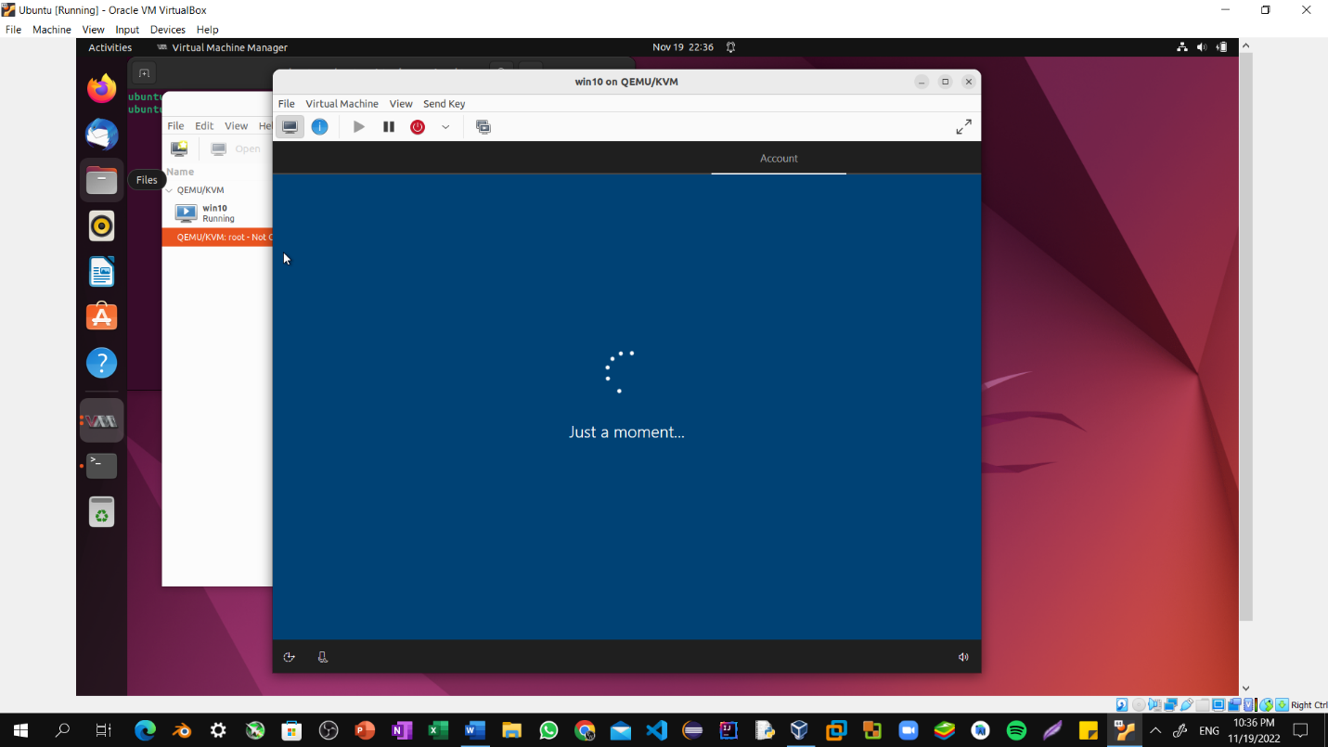

Step11: Setup pin for Windows workspace.

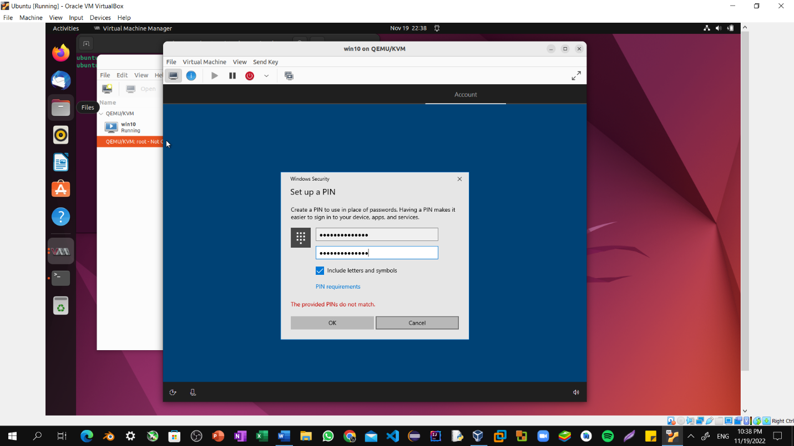

Step12: Windows 10 Workspace.

